L02 Exploring Deep Learning Tools A No-Code Introduction to TensorFlow and Keras

Martin Demel

Department of Science, Technology, Engineering & Math, Houston Community College

ITAI 2376 Deep Learning in Artificial Intelligence

Patricia McManus

January 22nd, 2025.

**Introduction**

In this laboratory assignment, I deepened my knowledge of deep learning without writing any code, as I focused on understanding the code and the steps involved. I used my personal laptop, a MacBook Pro with an M3 Max and Visual Studio Code. I worked with the pre-built VGG16 model and interactive widgets to engage in hands-on activities with pre-trained models, preprocess images, and make predictions. This laboratory assignment enhanced my understanding of deep learning concepts since I had previously explored related activities, such as data preprocessing, model architecture, and model predictions, during my computer vision course

**Body**

To start with, I refreshed myself on the concepts of deep learning by reading an article titled "Introduction to Deep Learning," by GeeksforGeeks. After reading the article, I started reviewing the provided code. This reminded me of essential concepts such as convolutional networks, layers, and the role of pre-trained models.

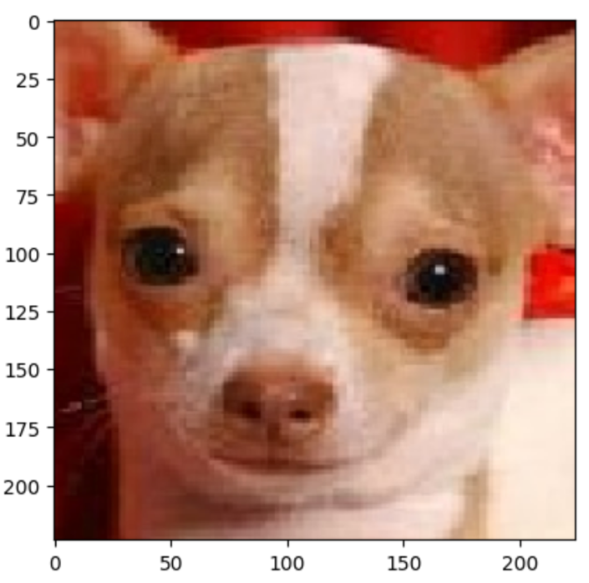The data loading and preprocessing reminded me of the pivotal role of ensuring that the input images match the model's expectations. One error I encountered during my testing was with images in PNG format. I realized that the model expects RGB and not RGBA (including alpha channels), which are provided by the PNG file. I addressed this with simple code to convert the image to RGB format. To conclude the data loading and preprocessing, I observed how preprocess_input further normalized pixel values to align with VGG16 training standards.

Figure 1—Chihuahua

For the sample image, I selected a Chihuahua (Figure 1) from my previous assignment—Chihuahua and Muffins. I enjoyed that assignment, which reminded me of how complex image predictions are. The model predicted the image without any issues. First, it identified the Chihuahua, second, the toy terrier, and third, the Italian greyhound.

As I progressed to actual prediction for images I uploaded via the interactive widget, I had to update the code accordingly, as I was getting the “tuple object has no attribute values” error. By reviewing the code and making simple adjustments to access the correct attribute—img_data = upload.value[0] [`content`], I resolved this issue.

After uploading the set of images for prediction, I learned that the model could face challenges when multiple objects are present in the picture or when the same image has different noise levels. For instance, I uploaded an image of my patio—Figure 2, that includes one mature grapevine tree and two grapevine roots. The model identified the image as a patio, but its second and third predictions were Komodo dragon and common iguana, which are incorrect.

Figure 2—Patio

I also tested slight modifications by rotating the image and adding a small amount of noise. Observing the model’s varying predictions demonstrated its sensitivity to these changes. The same image in Figure 2 - Patio was identified as a Walker hound, a birdhouse, and an English foxhound when rotated by 90 degrees to the right.

**Conclusion**

Working with a pre-built VGG16 model has enhanced my understanding of deep learning. I was unfamiliar with the use of widgets, but I learned that the color spectrum can also impact image preprocessing. I now have a clearer idea of how to troubleshoot such challenges in my future projects, and I appreciate how I have deepened my knowledge of deep learning techniques. Experimenting with input transformations reaffirmed the importance of consistent data. I will continue to explore deep learning techniques and how I can benefit from them in my professional experience.

**Resources:**

GeeksforGeeks. (2024, May 26). *Introduction to deep learning*. GeeksforGeeks. <https://www.geeksforgeeks.org/introduction-deep-learning/>